**Cheshire Cat (“Chess”)**

*Secondary protagonist and the primary info dump. He shows up during Beauty’s adventures early on and helps fill in her missing memories. He works under the Queen of Hearts, but strongly disagrees with the Queen’s ambitions to take over the entire world, claiming that a world with one ruler is a world without mysteries, and a world without mysteries makes no sense at all.*

**background**

A clever stray cat that first encountered the Queen of Hearts when he snuck into the castle for food. The Queen gave him some food and told him to serve under her, to which he happily complied. Since then, he has seen the Queen’s true colors and has come to the conclusion that he disagrees with her views of the world. As he puts it, “The Queen sees everyone as a chess piece and wants to be the master player. But I just want to watch the pieces play on their own. A game is only enjoyable in its unpredictability.”

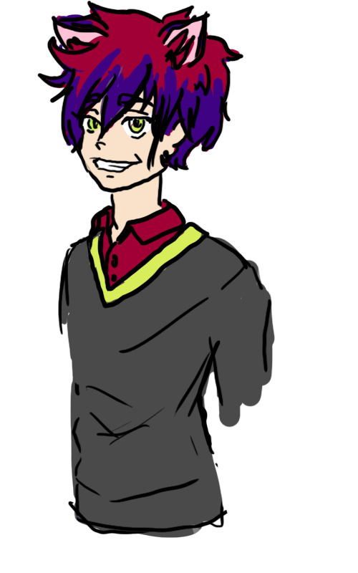

**physical appearance**

A cat with an abnormally large grin. He is always smiling. He has a reddish fur color that is fluffy, earning him the special favor of the Queen. Strangely enough, out of the entire Kingdom of Hearts, he is the only one that sports modern-style clothing. He favors comfortably clothes like hoodies or baggy jeans rather than skin-tight outfits. His favorite color is crimson.

**personality**

He is always smiling, but this smile can look cheery or menacing depending on his mood. The more cheery he looks, the more one should be wary.